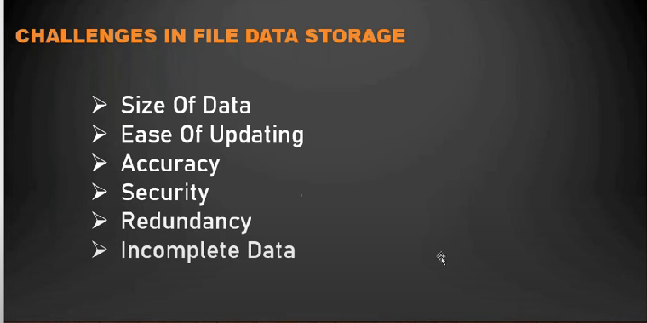

Before Database there is file system. So information can be stored in files. There used to be a restrictions in those times that the file should not exceed 10gb,etc… And if we copied same file in other folder for data availability, but if we want to update original file and we have to search for the copied file and should update it. And coming to security every one can access the file, and even it is ok if there is any missing data.

To Overcome all these problems, Database Concept was introduced.